Dress Code

Ask yourself – “Does what I’m wearing communicate Respect for myself and the Learning environment?”
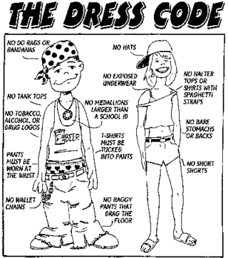

- Shorts or skirts higher than the ends of your knuckles when your arms are at your side with fingers curled into a fist
- Strapless tops or dresses
- No sunglasses or masks covering the face
- Midsections exposed when in normal posture
- Underwear exposed: Clarification – if a student is wearing shorts under jeans or sweats, they will be considered underwear and will be asked to cover the underclothes or wear just the shorts. This includes no showing of a bra or bra straps.
- Head gear: hats, hoods, and bandanas, except when worn for religious or medical purpose, which will require verification from religious leader or doctor order.
- Pictures of weapons, alcohol, drugs or other substances deemed illegal or inappropriate at school. This includes attire which is considered gang affiliated.
- Profanity or offensive material, words, phrases or graphics which contain inappropriate and/or suggestive material.
- All footwear must be appropriate for the school environment. (house shoes and slippers are not appropriate)
1st - 3rd Offenses: Student referred to student services at main or office at RAILS; option to change clothes or involve parent.
4th + Offense: Level II referral to appropriate grade level coordinator.
GO R.A.I.L.S.

